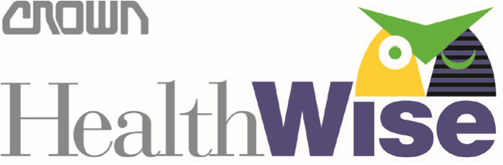

Health Questionnaire Reminder

As a reminder, both the screening and the questionnaire must be completed by 12/31/2022 to earn the $130 ($5/pay) HealthWise Credit in 2023.

Your lab results will be available to view at My.QuestForHealth.com within a week.

If you have not already done so, please complete the online health questionnaire so there is no delay in reviewing your results.

The online health questionnaire is found at My.QuestForHealth.com. Follow the instructions to log in or create your account.
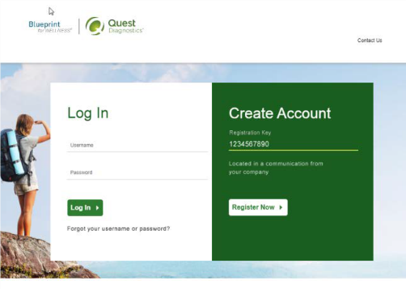

Returning User – Log In  - Enter the username and password you previously created.  - if you do not remember your login credentials, click ‘Forgot Username’ of ‘Forgot Password” Contact HealthWise if your recovery email needs updated.  - Complete Health Questionnaire  - You will receive an email when your results and personalized report are ready to view. | First Time User – Create Account  - Enter CROWN22 as the Registration Key  - Click Register Now  - Accept terms and conditions  - Enter EMPID and DOB to confirm eligibility  - Create username and password  - Confirm demographics  - Complete Health Questionnaire  - You will receive an email when your results and personalized report are ready to view.

Please contact HealthWise at ext. 14330 or at healthwise@crown.com with any questions.

